1. Determine the dual of each of the following linear programming problems.
(a) Maximize 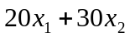
subject to
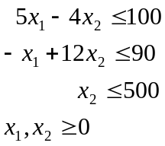
(b) Minimize 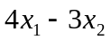
subject to
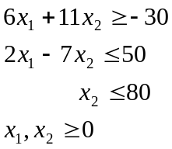
(c) Maximize 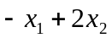
subject to
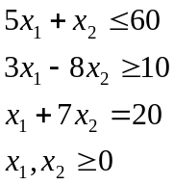
(f) Minimize 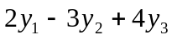
subject to
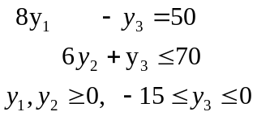

2. Consider the linear programming problem of Example 1 of this Chapter (Page 4-5).
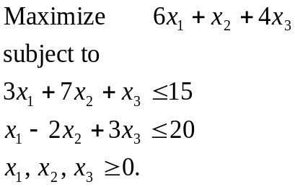
(b) Solve its dual problem graphically.
(c) Solve the maximization problem using the simplex method. Show that the optimal values of the primal and dual objective functions are equal.

